Each of the underlined words contains either a spejling or grammatical error. Write the  
correct word in each of the boxes. {42 marks)

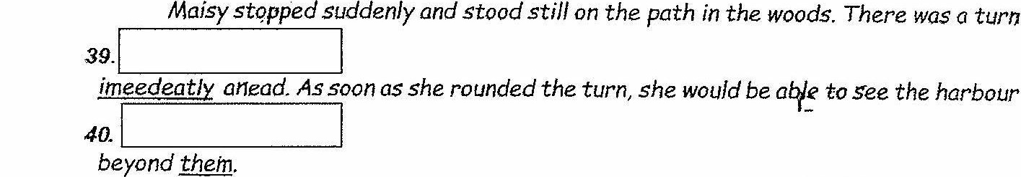

me  
However, she heard something else. She was certain it was not her (pore. She

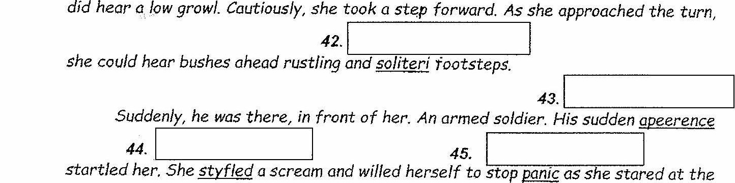

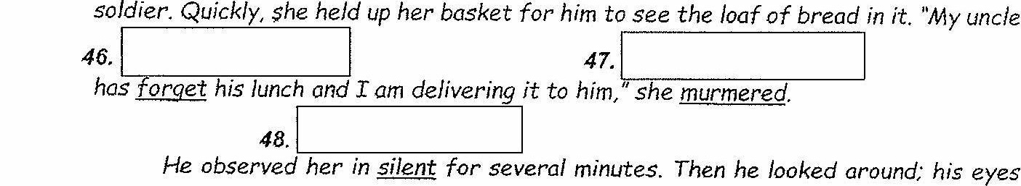

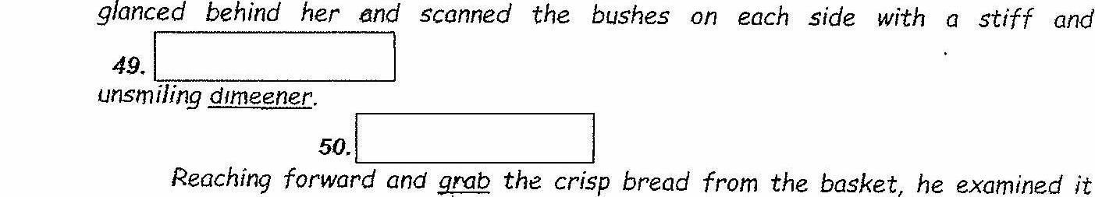

closely. Then he broke it in half, pulling the two halves apart with his fists

ee

Adapted from Number ihe Stars’ by Lois Lowry